Capstone Project - The Battle of Neighborhoods

Opening a Thai Restaurant in Colombo, Sri Lanka

1. **Introduction**
   1. **Background**

Colombo is the commercial and largest city of Sri Lanka by population. Also refer as the Commercial Capital of Sri Lanka. According to the Brookings Institution, Colombo metropolitan area has a population of 5.6 million and 752,993 in the City. Colombo is a multi-religious, multi-ethnic, multi-cultural city, and divided into 15 numbered areas for the purposes of postal services. Postal numbers and the City Districts (neighborhoods) are as below [1]:

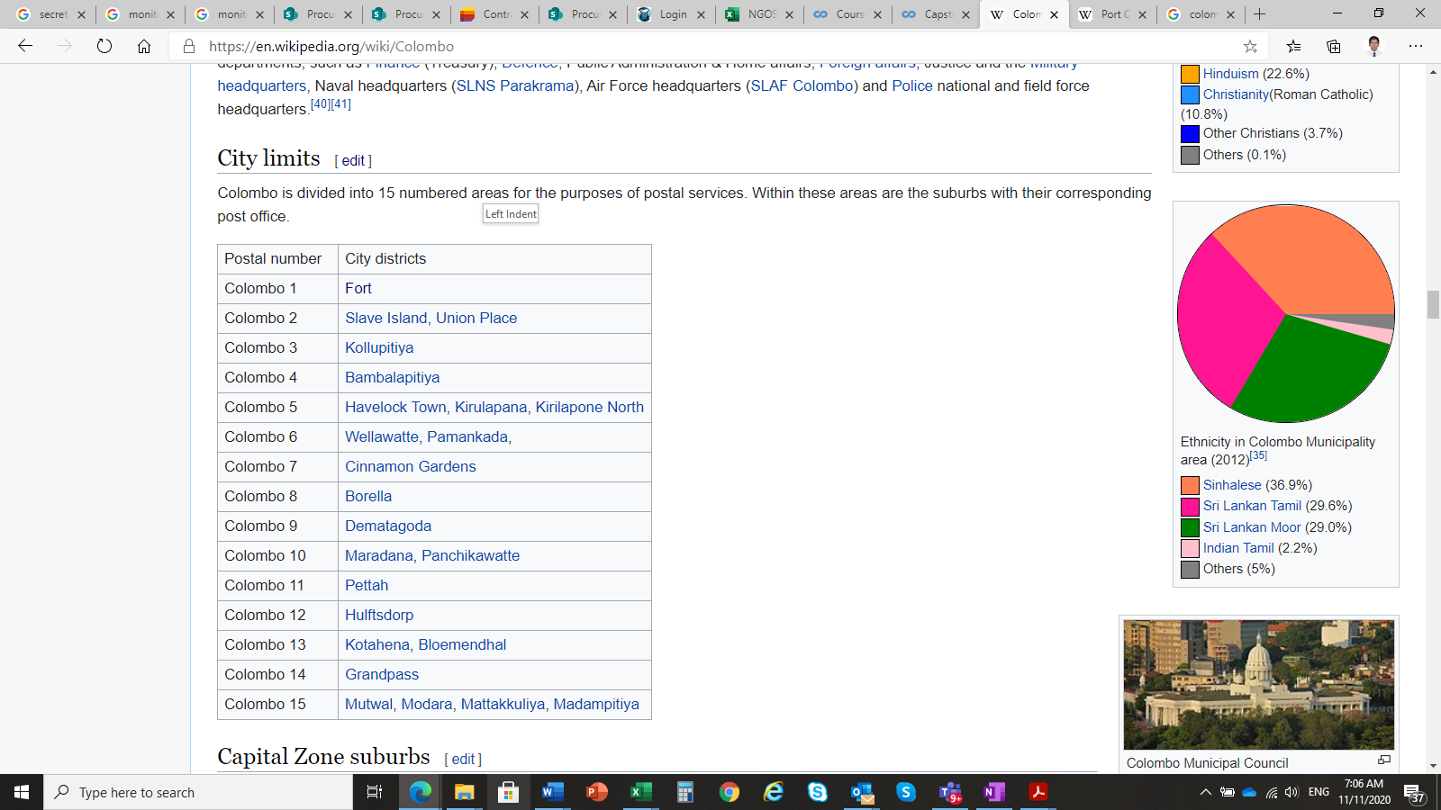

*The Colombo Metropolitan area has a GDP (PPP) of $122 billion or 40% of the GDP, making it the most important aspect of the Sri Lankan economy. The per capita income of Colombo Metro area stood at US$8623 and purchasing power per capita of $25,117, making it one of the most prosperous regions in South Asia. The Colombo Metropolitan (CM) area is the most important industrial, commercial and administrative centre in Sri Lanka. A major share of the country's export-oriented manufacturing takes place in the CM area which is the engine of growth for Sri Lanka.* [1]

Due its harbor and the strategic position along the East–West sea trade routes, Colombo has been known for trade more 2000 years. Currently harbor has expanded its capacity to handle large amount of cargo vessels in a day. In addition, Port City is under construction on reclaimed land adjacent to the port and will be developed as the special financial zone and International Financial Centre in Colombo. Majority of cooperate offices, hotels, restaurants and entertainment venues are in the city. New high-rise buildings are developing in the city with apartments, offices and shopping malls. These new add-ons will boost up the economy of the city as well as the country. It also majorly contributes to the ambition of Government of Sri Lanka to become the economic hub in the South Asian region. Due to developing environment and boosting economy, it will be good opportunity to the investors to open their business in the city area.

* 1. **Problem**

It is estimated that around 450,000 cars, vans, three-wheelers, motorcycles and 29,000 mass transit vehicles, mainly buses come into Colombo city carrying 1.8-1.9 million people on a daily basis. Jul 25, 2019 [2]

With the new development in the Colombo city area, becoming the economic hub in the South Asian region and the statistics shown in above, there will be more than two million foreign and local people will be engaged daily in the Colombo City. Due to this increase in population, there is a good demand for food and new opportunities are opening for food related businesses in the city of Colombo.

In this project, I’m focusing on restaurants and will investigate that if there is any good location in Colombo city for opening Thai restaurant and it really values to open one.

1. **Data**
   1. **Source of Data**

Following data will be used to achieve the objective of this study.

* Neighborhood data of Colombo city from Wikipedia. [1]
* Python geocoder library to get geographical coordinates of neighborhoods [3]
* Foursquare API venues explore method to get the venues of given neighborhoods of Bucharest [4].
  1. **Use of data to solve the problem**

There are 15 postal areas in the Colombo city. In some postal areas consist more than one neighborhood. So, first step is to obtain location values for each neighborhood from geocoder library and analyze Colombo city geographical structure. To analyze, folium library of python will be used to draw the map of Colombo city and its neighborhoods.

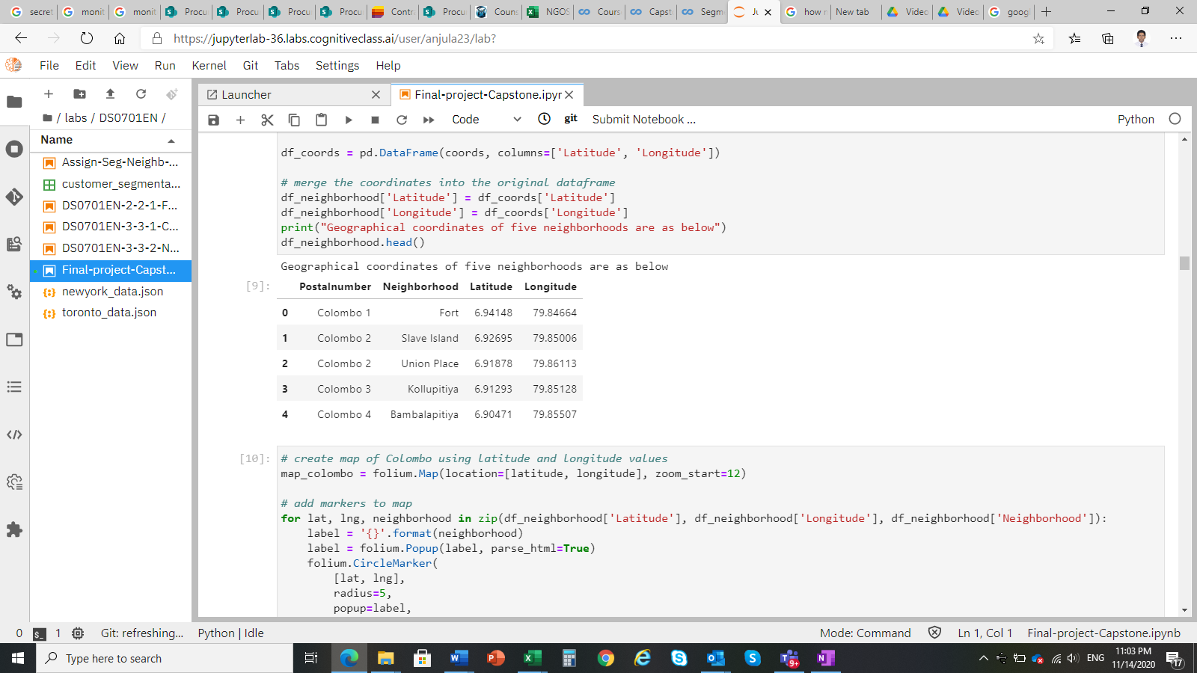

## Then using Foursquare API venues information, obtain each venue, venue category and venue location with respect to each neighborhood.

## 

The restaurants and Thai restaurants details will be extracted from above information to analyze restaurant distribution in neighborhoods.

## Venue distribution will be used to classify neighborhoods. Then analyze the similarities of the neighborhoods to identify locations that suit to open a new Thai restaurant.

## 

## References:

* [1] [Colombo — Wikipedia](https://en.wikipedia.org/wiki/Bucharest)
* [2] [Dailynews article on "Hassle-free travel in Colombo"](https://www.dailynews.lk/2019/07/25/features/192083/hassle-free-travel-colombo#:~:text=It%20is%20estimated%20that%20around,people%20on%20a%20daily%20basis).
* [3] [Python Geocoder Library](https://geocoder.readthedocs.io/)
* [4] [Foursquare API](https://developer.foursquare.com/)